**How to Get 10,000 REAL Youtube Views In A Week**

**Plus Add 1000’s of Subscribers In The Process!**



By YOUR NAME  
WEBSITE

**Copyright**

All content including images published within this ebook is protected by copyright laws. You may not reproduce or republish this work or change it in any way shape or form without first acquiring permission in writing from the lawful author.

**Disclaimer**

The Publisher has strived to be as accurate and complete as possible in the creation of this ebook, notwithstanding the fact that he does not warrant or represent at any time that the contents within are accurate due to the rapidly changing nature of the Internet.

While all attempts have been made to verify information provided in this publication, the Publisher assumes no responsibility for errors, omissions, or contrary interpretation of the subject matter herein. Any perceived slights of specific persons, peoples, or organizations are unintentional.

In practical advice books, like anything else in life, there are no guarantees of income made. Readers are cautioned to reply on their own judgment about their individual circumstances to act accordingly.

This book is not intended for use as a source of legal, business, accounting or financial advice. All readers are advised to seek services of competent professionals in legal, business, accounting, and finance field.

**Material Connection Disclosure**

You should assume that the publisher of this ebook has an affiliated relationship and/or another material connection to the providers of goods and services mentioned in this publication and may be compensated when you purchase from a provider.

Translation: I will get a commission if you click on a link in this email and you buy the product listed. I know, it's obvious, but I want you to be an informed buyer!

Remember, you should always perform due diligence before buying goods or services from anyone via the Internet, the same as you should buying offline.

You are encouraged to print this ebook for personal easy reading :)

***Highly Recommended!***

**Tube Toolbox: Get Youtube More Views, Likes, Subscribers and Friends By The Boat Load Automatically!!**



[**Download Your Free Tube Toolbox Software Now!**](http://www.TubeToolbox.com/?Secure=A1692)

**What is Tube Toolbox?**

Tube Toolbox is software that automates your daily video marketing tasks. It allows you to **reach up to 100x more YouTube users** than you could on your own. Tube Toolbox can run in the background while you work on other projects or even while you sleep.

The process of using Tube Toolbox is broken up into two steps...

It **1) finds people** who would be interested in your videos for you and **2) contacts them** asking for friend requests, sends messages and leaves comments **completely hands-free!**

[**Try Tube Toolbox Free Today!**](http://www.TubeToolbox.com/?Secure=A1692)

Contents

Introduction 5

1. Write An Interesting & Descriptive Title For Your Video 6

2. Write A “Descriptive” Description 7

3. Add Keywords In Your Tags 9

4. Share Your Video On Facebook & Twitter 11

5. Get As Many Likes and Comments As Possible 12

7. Make Your Video A “Video Response” To A Popular Related Video 13

8. Make Your Video Go Viral 14

9. Get Subscribers to Your Channel 16

10. Use Links To Your Other Videos In Annotations 18

11. Post Your Video to Your Blog or Website 19

12. Post Video On Forums 20

13. Submit Your Video To Other Video Sharing Sites 21

14. Promote Your Video On YouTube 23

15. Bookmark Your Video(s) On News/Social Bookmarking Sites 24

Conclusion 25

# Introduction

So you wanna get 10,000 REAL views on your Youtube video! Great! This ebook will show you 14 surefire ways to explode your views and subscriber count in a short time.

There are many reasons why you may want more views to your videos. It could be that you’re in business or just simply want to be famous. Whatever it is, video is the greatest promotion tool on the net.

You can leverage the power of video to get people’s attention and win customers and fans. This guide will help you get more views and subscribers to help build your fan base.

In order to get 10,000 views, there are many factors that come into. There is usually not just one factor alone that will be responsible for your video getting 10,000 views alone.

For the most of us Youtubers, your views will come from all over the web, not just from one source.

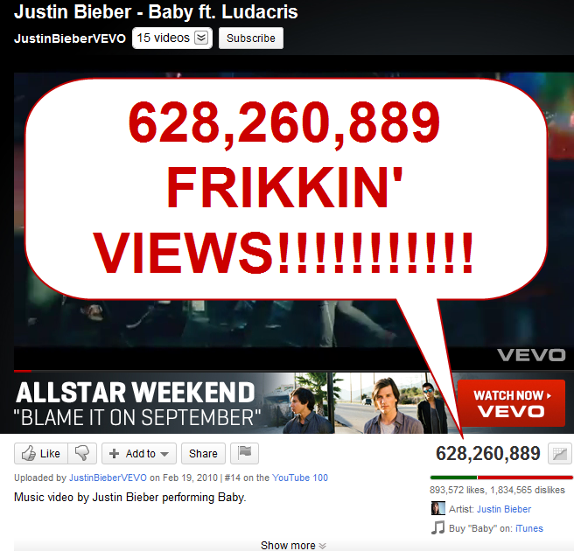Some will come directly from YouTube and some will come from other sites so be willing to spread your efforts and you will get the views you’re chasing. Remember, the more effort you put in, the more you get out.

If you can make a totally awesome video that goes viral like the Ken Block Gymkhana videos or have some kind of famous, cute, funny person or big breasted woman starring in your video, your job of getting people to view and share it is going to be easy!

Once a video goes viral, there is pretty much no stopping it. Some of the most popular viral videos on YouTube have over 600 MILLION views!

If you’re not Justin Bieber, you’re going to have to do a little more “work” and rely on a collection of other factors to get views.

If you’re lucky, maybe somewhere along the way, your video might get picked up by some big websites or big people online and it will go viral, but don’t hold your breath.

Make the videos you want to make and share them using these tips. I can’t guarantee you’ll get 10,000 straight away, or even in your first week, but if you use any or all of these tips, you might be surprised.

# 1. Write An Interesting & Descriptive Title For Your Video

When you are inside your YouTube account and have uploaded your video, you will be asked to fill in some fields to describe your video. The first one being your video title.

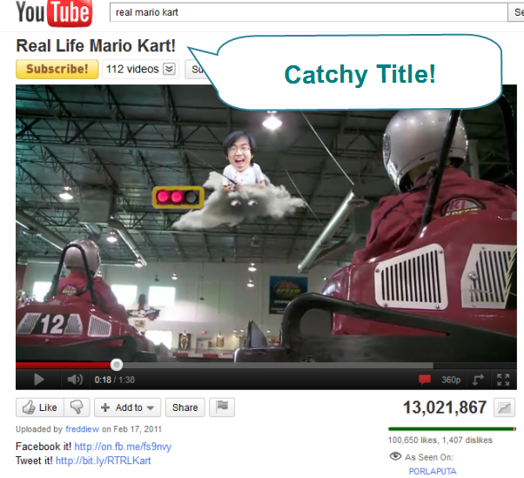

Be as descriptive and cool as possible when writing your title for your video.

Youtube and humans can’t tell what is actually in your video before they watch it, so you have to let them know as best you can with your title.

The words in your title determine how Youtube lists your video in the search results when someone performs a search. And not only the Youtube search results look at the words in your title, but also Google and other search engines will list your video according to the “keywords” in your title.

Usually, one or two word titles are not enough and seem boring and don’t give a clear explanation to the viewer.

Instead of writing “soccer” as the title, write a more detailed one such as “Playing Soccer at Garden Square Stadium”.

Another point is the capitalize the first letter of every word in the title. This makes it stand out more so people are more likely to click on your video over someone else’s.

And don’t be afraid to get a little creative when you write your video title. An interesting title will get a lot more clicks than a boring title. Just make sure you still are detailed in the description and not be misleading.

# 2. Write A “Descriptive” Description

Along with a descriptive title, your video description should contain descriptive words to explain your video even more.

Your description doesn’t need to be very long. On average just a paragraph or two explaining the contents of your video and any details about it you want viewers to know about it.

Also, you should **try to contain your “keywords”** (words that when people search for will find your video) in this area.

Adding “keywords” into your description (as with the title) is very important for your video coming up in the search results. If you have the same keywords as you title, then Youtube will know that your video is definitely about “your keyword” e.g. “playing soccer” “garden square stadium”.

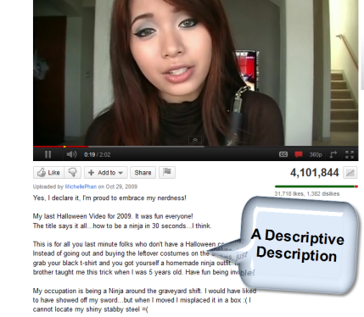

A bit of a ninja tactic with your description is that you can add your website URL (address) and it will turn into a clickable hyperlink.

Just make sure it starts with **http://** and it will be clickable. This is only if you want people to go to another page after watching your video so if you don’t have a website of your own, you don’t need to worry about this.

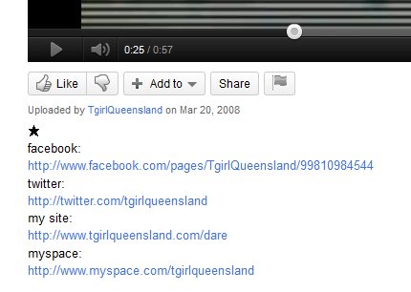

# 3. Add Keywords In Your Tags

Again on the topic of Keywords, you’ll see when you go to upload your video, a field where you can add tags or keywords.

These are also used to find and list your video in the search results when a user goes to search.

So again, you’ll want to add as many relevant keywords in here that you want. You don’t need to go overboard here.

**A good number is about 5 to 10 keywords.** Anything more than that and you’ll look spammy.

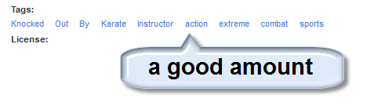

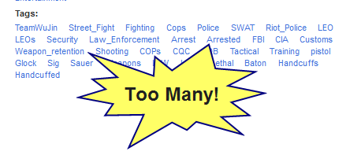

Youtube tells you that you can separate your tags with spaces. For example, if you type in the tags field like this: *play soccer garden square stadium*; you will get 5 different keywords.

1. play

2. soccer

3. garden

4. square

5. stadium

But what if your keyword is more than one word.. or a string of words?

e.g. “garden square stadium”

**Here’s a trick to get a multi-word keyword show up as a single keyword.**

If you type your keywords between quote marks, like this: “twitter marketing” “make money” “mlm lead system”; then you’ll get groups of words that will end up as single multi-word tags.

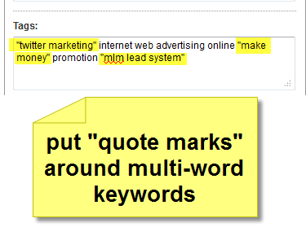

This whole thing about “keywords” and “tags” and getting your video to show up in the top of the search engines (youtube and google) is related to the big picture of internet marketing and SEO (search engine optimization).

Internet marketers are making a killing with their videos so if you want to learn how get a piece of that action with #1 rankings for your videos check out this nifty piece of software called [**Video Shadow**](http://stuart81.vidshadow.hop.clickbank.net).

This software lets you find the exact keywords you can use to get your videos ranking in the #1 position and also uncovers the tactics used by competitors so you can beat them at their own game.

If you’ve got a business or just want a way to make some money on the side, video marketing is the way to get people’s attention and it’s only going to get bigger.

You can use [**Video Shadow**](http://stuart81.vidshadow.hop.clickbank.net) to help you get the advantage and beat everyone else to the top position the easy way.

# 4. Share Your Video On Facebook & Twitter

After you’ve uploaded your video with a good descriptive title, description and added your tags, now it’s time to share it with the world.

The first choice for most people these days is Facebook and this is the first place I’m going to recommend to you to go and share your video.

**There are four main places to share Youtube videos on Facebook:**

1. 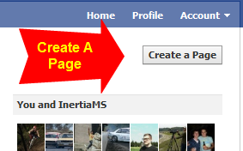Your own wall
2. Your page’s wall (if you don’t have your own page yet, [go and create one](https://www.facebook.com/pages/create.php)! it’s free and easy to do)
3. Wall’s of pages that are related to your video (remember not to spam - make sure the people are going to like your video)
4. Directly with friends via a message

When you share the link to your video on a wall or in a message, it usually comes up with a thumbnail of your video. If it doesn’t, refresh the page and paste the link again until the thumbnail comes up. Videos without a thumbnail won’t get watched!

The next best place to share your video is on <http://twitter.com>

If you haven’t got a Twitter account yet, go and get one. It’s free to join and it’s easy to make friends and get “followers” who are interested in the same stuff as you.

The good thing about Twitter is that it’s just another avenue for you to share your video and things (e.g. cool videos) get shared around on Twitter like it’s nobody’s business.



If you haven’t got any Twitter followers, you can manually search around an follow people who are into the same thing as you and hope they follow you back or you can use a service like [**Twittollower**](http://twittollower.com/amember/go.php?r=767&i=l0) which **will automatically find and add followers** to your Twitter account.

# 5. Get As Many Likes and Comments As Possible

One other factor that plays a role in where your video will rank in the search results in Youtube and Google is the number of likes and comments your video has received.

The more you have, the more ‘important’ your video looks to Youtube and Google.

Naturally, if your video is good and people like it, they will comment and give it a thumbs up without any effort on your part.

If your video is a little controversial, funny, sexy or cute, the chances of them commenting or rating it goes up.

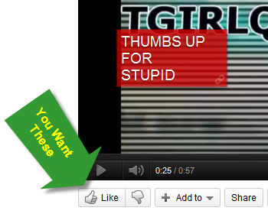



To boost the chance of people commenting on your video and liking it is to just simply ask your viewers to do so. You can use a frame at the end of anywhere in your video or add an annotation that says “Like this!” or “Please comment!”. Just like the Bible says, “ask and ye shall receive.” It never hurts to ask.

**If you are too lazy** to ask for comments or make a video that could be shared virally, you can still get comments, likes and views on complete autopilot with the automatic video marketing software [**TubeToolbox**](http://www.TubeToolbox.com/?Secure=A1692). This software will take care of your video views and likes while you sleep. If you haven’t check it out yet, [download it and try it for free!](http://www.TubeToolbox.com/?Secure=A1692)

# 7. Make Your Video A “Video Response” To A Popular Related Video

This is how you can leach views/viewers from other videos that are popular and getting a lot of views.

To post a video response, you just put your cursor in the comment box of that popular video and click your mouse.

On the right of the box you’ll see **“Create a video response”** appear so click that. Then you’ll be able to choose one of your videos as a video response to the popular video.

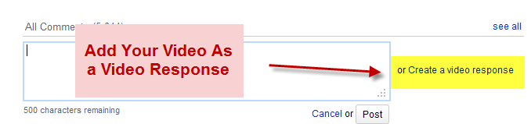

This doesn’t always work because some Youtubers manually approve video responses so they might reject yours if they don’t like it.

If your video does get approved, a thumbnail and link to your video will appear under the popular video and be seen by all who view it.

Note that you can only use 1 of your videos for 1 video response, so if you thought you could use your 1 video to add video responses to every video you come across, sorry but you can’t do that.

If you upload the same video several times with different title, keywords and description, you can add each one as a video response.

This method can give you a whole lot of free views very quickly if a video you’ve responded to goes viral and gets a lot of views.

# 8. Make Your Video Go Viral

I mentioned in the introduction of this report that if your video is extremely cool, i.e. has someone famous, extremely lucky, a girl with big boobs, someone who is stupidly funny or cute, it will go viral and get thousands, even millions of views by itself.

In other words, it needs to have **“entertainment value”,** because that’s what 99% of the people on Youtube (and the whole internet) are there for - entertainment.

In this rare case that is does go super viral, it doesn’t matter about your title, description or keywords. People are going to be sharing it and it will spread like wild fire.

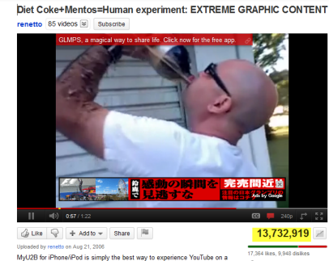

Unfortunately, not everyone can produce videos that go viral like some of the ones you and I have seen. In most cases, those videos contain things that just happen by chance and the guys behind the camera were lucky enough to “catch it on tape”. They are seldom planned.. but sometimes they are.

I’m betting if you were around online in 2010, you would have seen the Mentos and Diet coke experiment videos. Catching ontop a craze like this and making a video about it can end up with a lot of views!

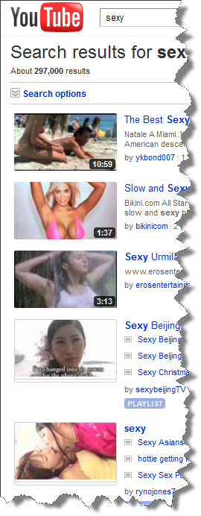While we can’t always be lucky enough to have our cameras ready when a girl fight breaks out or when a horse swings and throws a ball at you, you can make your videos clever and entertaining.

If you really want your video to go viral, **you can make it happen**, it just needs some prior thought and planning.

Incorporate these things in your video and you have a better chance of it going viral.

* Funny e.g. parody
* Stupid
* Rare talent
* Extreme
* Controversial
* Helpful e.g. “How to” tutorial
* Professional e.g. HD, high quality, professional production
* Original
* Sexy (it’s true.. sex sells)

These are the common elements you’ll find in most viral videos. I’m not saying to use all these in the same video, but if you can make it funny and a bit controversial.. maybe even a little sexy, then you stand a good chance of people going crazy over it and reaching a bigger crowd.

# 9. Get Subscribers to Your Channel

If it’s numbers you’re after, then getting subscribers is the sure-fire way to guarantee you get views to your videos.

The main benefit being that whenever you upload a new video, all of your subscribers will see your new video’s thumbnail when they log in next time to Youtube.

If you have 10,000 subscribers, then straight away you almost have a guaranteed 10,000 views in the bag without doing anything.

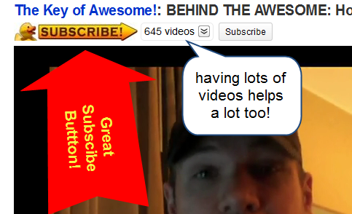

But the hard part is that we all start with ZERO subscribers and build up.

**So how do you get subscribers?**

First of all it’s pretty hard to get subscribers if you don’t have many videos. Usually, people will subscriber after they check out a few of your videos and decide “hey, this guy makes cool videos.. I want to watch more!”

**The more videos you have uploaded and live on your channel the better.**

Keep your videos all related to one topic. *Consistency is key.*

If you have videos about all types of things, like scenes of a basketball game you’re in or a video of a family BBQ, it’s not going to get people to like your channel.

That’s why there is the sports channel, the movie channel, news, documentaries, MTV all on separate channels on normal TV. There is a reason why those corporate TV stations don’t mix genres.

And again with the “entertainment value” factor, your videos need to be entertaining or you just won’t be able to keep your viewer watching - or even think about subscribing.

The best way though to get subscribers, even if your video is just average, and that is to **ask viewers to subscribe**.

Just like asking for your viewers to LIKE your video or comment, you can ask them to subscribe. A few of the more popular Youtubers use a Jingle in their videos that are catchy and get people to subscribe. It’s easy to think up a little jingle or a cool catch phrase to add at the end of every video you make.

If you’re not real creative when it comes to jingles or catch phrases, a simple request to “subscribe” is effective. Remember, if you don’t ask, you may never get any subscribers and there is no harm in asking!

Unfortunately, getting subscribers can be a bit challenging. If you want to **take the easy way out** and get subscribers and likes all without lifting a finger, then you should check out and [try the automatic TubeToolbox software for free](http://www.TubeToolbox.com/?Secure=A1692).

# 10. Use Links To Your Other Videos In Annotations

This is another trick that big time Youtubers do to really ramp up their video views.

They use Annotations to link to their others videos. Sometimes, they link to several videos from one video.

You can use them too. They are simple to do. Just create an annotation after your upload and your video goes live. Then you can go back and **“edit” your video** and insert your link(s) to your other video(s) by adding them in annotations.

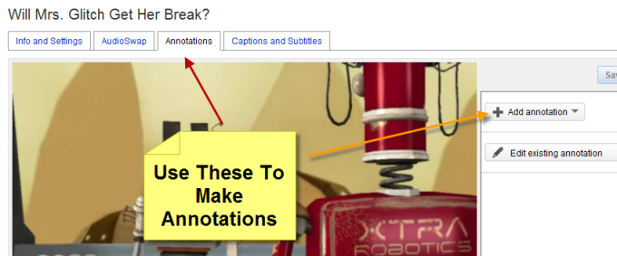

You can add annotations to show all the way through your video, at the end or at any time and for any length of time. It’s up to you when you want to use them.

If you have ever followed a Youtuber’s videos that uses annotations to link up all their videos, you would have found yourself caught in a “web” of their videos and be on the 10th video in a row from them without you even noticing.

So it really does work.

# 11. Post Your Video to Your Blog or Website

If you have a blog or website that gets lots of visitors, you can easily boost your views by placing your video on there.

If you don’t have a website yet, why not?

There are plenty of places to create free websites online such as <http://blogger.com> and [http://weebly.com](http://affiliate.weebly.com/scripts/click.php?aid=4e7ddf46b40c2&cid=d4aceefd)

There are many benefits of having your own website, especially if you own a business or want to gain a following online.

If you want to get a website of your own up and running online that is not hosted on another website like the ones I mentioned above, you can do that too but there are some costs involved.

For instance, you’ll need to register a domain name and get website hosting (average cost of around $60/yr).

It can be a little daunting to put together a website from scratch if you’re a beginner to websites, but luckily there is plenty of information on the web on how to do it all such the [**Newbie Start Up Guide**](http://newbiestartupguide.com/)  ebook which makes things easy for you.

Once you’ve got your website up and running, it’s easy to post your video.

Just find your Embed code and do a quick copy and paste, publish your page and it’s live!

Here’s a cool tip: If you have some social site share buttons like <http://sharethis.com> on your web page, then people can share it right there without leaving your web page.

# 12. Post Video On Forums

Are you a member of an online forum?

There is an online forum for just about any hobby, sport or group with the same interest.

If you’re into extreme sports like downhill mountain biking or base jumping, there are several online forums full of people who love it just like you.

These forums have 1000’s of active members who are keen to check out new and exciting videos, and you can easily get their eye balls by simply posting your video to a new or popular thread.

Just make sure you are posting your video in a related forum. Don’t post your “how to make money online” in a snowboarding forum. That’s just not cool.

No one likes spam, so don’t post anything that will annoy people. Because forums are full of real people, and they are usually in the forum a lot, they can smell a rat (or spammer) from a mile away.

If your video is pure entertainment, then it’s fine to post it in any related forum you are a part of. But if your video is just an ad to get people to go to a site somewhere or buy something, you (and the forum members) won’t be a happy camper.

If you’re not a member of any online forums, go out and search for some and join them.

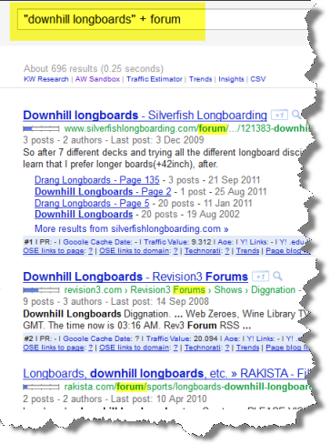To find an online forum where there are similar people with the same interests as you, just do a search like this in Google:

***“your hobby/topic” + forum***

You’ll get a list of all the popular and active forums. Of course, make sure it is active. You won’t have much fun (or get people to watch your video) if the forum is dead.

Also, make sure the forum isn’t full of spam, because sometimes they can get taken over with spam and that is not where you want to be.

Cool tip: **Put your link to your video or website or Youtube channel in your Signature file.**

You can edit your Sig in your forum account and most forums let you put anything in there (like images or big clickable text)... add something that catches the eye.. as long as it’s not too big or spammy.

# 13. Submit Your Video To Other Video Sharing Sites

Youtube isn’t the only video sharing site on the web. Sure it is the biggest but there are hundreds of others out there that you can tap into for even more views.

Some popular “mainstream” ones include

<http://metacafe.com>

<http://dailymotion.com>

<http://viddler.com>

<http://vimeo.com>

<http://blip.tv>

<http://veoh.com>

Then there are a heap of other ones related to other topics like for comedy or stupid videos there is <http://break.com> <http://www.ebaumsworld.com/> and many more.

For “How to” videos, submit to <http://www.howcast.com/> and <http://videojug.com>

There are video sharing sites for other “niche” topics like extreme sports, music and dancing etc.

To find video sharing sites for your topic, just do a search in Google again for “your hobby/topic” video sharing e.g. search for “hunting video sharing sites”

In these videos, you can also promote your videos on Youtube and your Youtube channel. You can add it as a scene in your video or put your link to your Youtube video/channel in the description area.

It can be pretty hard, boring work to submit all your videos my hand to multiple video sharing sites, so you may want to consider investing in some software like [**Traffic Geyser**](http://www.TrafficGeyser.com/cmd.php?af=68079) to automate it as much as possible.

Traffic Geyser can submit your video automatically to around **35 video sites at once**. So it will save you a lot of time. It can also provide you with more services than that. If you’re a podcaster, it can submit your podcasts to multiple directories as well as do many other things.

Traffic Geyser is not free however, and unfortunately there are no free multi-upload services that I could find. But you can try <http://heyspread.com/> which will let you submit your videos to multiple sites on a “pay as you go basis”.

# 14. Promote Your Video On YouTube

This is only if you are really serious about getting a lot of views and subscribers because it’s going to cost you a lot to of dough to promote your video on Youtube.

<https://ads.youtube.com/>

This how Youtube Promoted videos works..

* Upload a video of any length
* Target your video by keyword or category
* Decide where you want your ad to appear (search results, suggested videos)
* Set your own budget and bid price for your targeting options

You can control your budget because you only pay when someone watches your video.

Again, this is serious advertising we’re talking about here so only do this if you’re prepared to spend money to get views and subscribers. If you have a business or are a musician, actor, comedian or have any skill you want to get seen, then this is a good way to get seen by millions fast.

# 15. Bookmark Your Video(s) On News/Social Bookmarking Sites

After your video is uploaded to Youtube and any other video sharing site, or posted into a forum or on your site or other web page, you can go and submit those links to social bookmarking sites.

This is just another way to share your video and get it out to the masses. It also increases your chances of your video appearing in Youtube and Google search results.

Each bookmark to your video or video page is a “backlink” and backlinks are seen as important in the eyes of search engines. The more backlinks a page has, the most it’s seen as important.

Here’s a list of popular social bookmarking and news sites where you can submit your pages to:

<http://digg.com>

<http://stumbleupon.com>

<http://propellor.com>

<http://reddit.com>

<http://delicio.us>

<http://fark.com>

<http://www.slashdot.org/>

<http://www.friendfeed.com/>

In order to submit to all these places, you’ll need to sign up and create a free account with all of these sites.

Then you’ll have to go to each site and submit each link manually to them. This can be quite tedious and time consuming.

Luckily there is a way to semi-automate your bookmarking submissions with the use of <http://socialmarker.com>

The great thing is that Social Marker is free to use but it does take a fair bit of time to go through and submit your links. You need to have accounts at the sites and be logged in to the sites to use them. It’s still better than going to each site manually and submitting that way.

If you want a **100% hands-free social bookmarking solution**, try [http://socialadr.com](http://socialadr.com/join/?a=360194) . With [**SocialAdr**](http://socialadr.com/join/?a=360194), you simply submit your url (your video url or any web page) once and other people who are members of that site will submit it all around the web for you.

There is a free version and a paid version if you just want to completely put your bookmarking and backlink building on complete autopilot.

# Conclusion

Using a combination of all of these strategies, you will see your view counter spin up to the thousands and beyond in no time. It does take a little time and effort to first make a good video and then promote it, but you only get out what you put in.

If you have an end goal in mind for wanting to share your videos, e.g. get more customers for your business, or build your fan base, or get members to your site video is a great way to go about achieving it.

And the more views you get, the more business, fans, friends and followers you will get. So all that’s left now is to go out there, get off your butt and start following these steps!

***YOUR NAME***

YOUR WEBSITE OR CONTACT EMAIL

***Highly Recommended Make Money Online Products***



**Free Ebook!**

***“An Idiot’s Guide To Getting Rich Online”***

[**DOWNLOAD HERE**](http://www.startmyebiz.com/gifts/idiotsguide/)

**Free ‘Turnkey’ List Building & Money Making Websites - $197 Value**

* ***Free Squeeze Pages***
* ***Free Re-Brandable PDF***
* ***Free Email Follow-Up Messages***
* ***Multiple Built-in Profit Streams***

***The Easiest Online Money Making System On The Web!***

[**Click Here To Get Your Free Membership!**](http://turnkeycashkits.com)